

**HIMACHAL TOURISM**

**PROJECT REPORT**

Submitted in partial fulfilment of requirements for the award of diploma in **COMPUTER ENGINEERING**

**SUBMITTED TO:- SUBMITTED BY:-**

Mr. NISHANT SHARMA VISHAL CHAUHAN

ACHINTYA DWIVEDI

PALLAVI DEVI

VIDISHA VERMA

ANKUSH LAGWAL

DEPARTMENT OF COMPUTER ENGINEERING

ABVGIET Pragatinagar Distt.Shimla

Himachal Pradesh

**CONTENTS**

* PROJECT EXECUTION REPORT
* ACKNOWLEDGEMENT
* PROJECT TITLE AND CATEGORY
* DEVELOPMENT ENVIRONMENT
* GANTT CHART
* INTRODUCTION
* REFERENCES
* METHODOLOGY
* CODING
* SNAPSHOTS
* SCOPE OF THE PROJECT

PROJCT EXECUTION REPORT

|  |  |  |  |
| --- | --- | --- | --- |
| Serial no. | Name of phase | Last date | Remarks |
| 1. | Synopsis submission |  | Synopsis submission for approval. |
| 2. | Requirement analysis |  | Analysis of functional operational & technical requirements. |
| 3. | Conceptual design |  | Design of database model. |
| 4. | 1st review |  | Review of all previus phases. |
| 5. | Implementation and test cases |  | Submission of running project and implemention of test cases. |
| 6. | Final review |  |  |

ACKNOWLEDGEMENT

We Himachal Pradesh Tourism Team hereby acknowledge the crucial guidance, related research, for their patience, motivation and immense knowledge of our project mentor Mr. Nishant Sharma. Their guidance helped our team in all the time of project. Hence , we are very thankful for his help and guidance.

I thank my fellow groupmates in for the stimulating discussions,help and support because there is equal contribution of all of the groupmembers. We were working together before deadlines and also I thank my friends in the A.B.V.G.I.E.T. Pragatinagar.

Last but not least, I would like to thank my family: my parents and to my brothers and sisters for supporting me spiritually throgthout every way of my life.

PROJECT TITLE AND CATEGORY

**TITLE OF THE PROJECT:- Himachal Tourism**

**Category:-**This project is related to a specific information website build up on the HTML, CSS & PHP.

In this we have provided information about all the best places to visit in Himachal Pradesh for tourists.

**DEVELOPMENT ENVIRONMENT**

|  |  |
| --- | --- |
| Processor | Core 2 and above |
| Motherboard | Intel 915 and above |
| RAM | 2 GB and above |
| Hard Disk | 2 GB |
| Network Card | Standard Ethernet card for networking. |
| I/O Devices | Keyboard, mouse and Color monitor |
| Wires | Twisted pair for networking. |

* **HARDWARE REQUIREMENT**
* **SOFTWARE REQUIREMENTS**

|  |  |
| --- | --- |
| Operating System | Windows 10 and above. |
| Environment | PHP |
| Front-end Tool | Html ,css , javascript ,php |
| Back-end Tool | Mysql(xamp) |

**GANTT CHART**

|  |  |  |  |  |
| --- | --- | --- | --- | --- |
| Time | | | | |
| Tasks | March | April | May | June |
| Task A |  |  |  |  |
| Task B |  |  |  |  |
| Task C |  |  |  |  |
| Task D |  |  |  |  |

**Task A:-**

Requirement gathering and Software Project Management.

**Task B:-**

Designing GUI/Modules.

**Task C:**

Coding of modules and Database Connectivity.

**Task D:-**

Testing and Implementation.

**About US**

**Travel and Tourism in Himachal Pradesh**

Tourism is travel for leisure, recreational and business purpose. Tourists can be defined as people who travel to and stay in places outside their usual surroundings for more than twenty-four hours and not more than one consecutive year for leisure, business and other purposes by the World Tourism Organization. Tourism is a known affair in human life. It has been an industry of vast dimensions and eventually supports economic and social growth. Tourism worldwide has experienced phenomenal growth. With more than 600 million people travelling annually, tourism is the world’s largest industry, with revenues of about half a trillion dollars a year, and averaging five percent annual growth.

**INTRODUCTION**

**PROJECT NAME:- Himachal Tourism**

I do hereby declare that this project work entitled “__HIMACHAL TOURISM__” submitted by Tourism Team Group A(leet). The report embodies the finding based on our study and observation and has not been submitted earlier for the award of any degree or diploma to any Institute or University.

In our project, we have provided information the all best places to visit in Himachal Pradesh for tourists.It is much usefull for the tourists who is being confused after visit in Himachal Pradesh.

In our project we have provided the informations like best Tourism Places, Tourism Services (bus, taxi, train & air), Hotels, Address and the Contact Info of all these services .

The HTML language is used mainly to develop it. As we says earlier that this project is related to a static information website build upon the HTML .

Himachal Tourism (Project) Submitted to: ABVGIET Pragatinagar (Gumma) SHIMLA :Under the Supervision of: Mr.Nishant Sharma .

* Name of Students Roll No

1. Vishal Chauhan 20072330-4009
2. Achintya Dwivedi 20072330-4016
3. Pallavi Devi 20072330-4002
4. Vidisha Verma 20072330-4006
5. Ankush Lagwal 20072330-4005

*REFERENCES*

* TEACHERS
* INTERNET
* [www.google.com](http://www.google.com)
* [www.w3schools.com](http://www.w3schools.com)
* [www.htmltutorial.com](http://www.htmltutorial.com)
* GROUPMEMBERS
* FRIENDS

**Methodology**

**HTML:-**Sat

2012

There are two parts in website one is design and other one is development. For developing good website you should do design of website very well. For design mostly designers use HTML language because it is the primary language and easy to use by designers.

HTML stands for Hyper Text Markup Language. It is simplest language which is created by human beings and it is used for creating static websites to provide information to humans.

**CSS:-**

When you create a website for your business, time and money are likely to be major concerns. Luckily, there is a web design method that can help you save time and money while also improving your visitor's experience.

Cascading Style Sheets, more commonly known as CSS, has fast become the preferred web design method for the benefits it offers web designers and website visitors alike.

CSS is a language used to detail the presentation of a web page's markup language (most commonly HTML or XHTML) – such as colors, fonts, and layout. One of its key benefits is the way it allows the separation of document content (written in HTML or a similar markup language) from document presentation (written in CSS).

**JavaScript:-**

It is used in millions of web pages to improve the design, validate form, detect browsers, and creates cookies and much more. Java Script is the most popular scripting language on the Internet, and works in all major browsers, such as Internet Explorer, Mozilla Firefox, Netscape, and Opera.

Java Script was design to add interactivity to HTML pages. It is scripting language. It consists of line of executable computer code. It is usually embedded directly into HTML pages. It is an interpreted language. Everyone can use java script without purchasing a license. It is most widely used for validation and dynamic effects.

**PHP:-**

PHP is a server-side scripting language. PHP (recursive acronym for PHP: Hypertext Preprocessor) is a widely-used open source general-purpose scripting language that is especially suited for web development and can be embedded into HTML.

The best things in using PHP are that it is extremely simple for a newcomer, but offers many advanced features for a professional programmer. Don't be afraid reading the long list of PHP's features. You can jump in, in a short time, and start writing simple scripts in a few hours.

There are three main areas where PHP scripts are used:

* Server- side scripting.
* Command line scripting.
* Writing desktop applications.

**INTRODUCTION TO MYSQL SERVER:-**

The MySQL server provides a database management system with querying and connectivity capabilities, as well as the ability to have excellent data structure and integration with many different platforms. It can handle large databases reliably and quickly in high-demanding production environments. The MySQL server also provides rich function such as its connectivity, speed, and security that make it suitable for accessing databases.

SQL stands for “Structured Query Language” and can be pronounced as “SQL” or “sequel – (Structured English Query Language)”. It is a query language used for accessing and modifying information in the database. IBM first developed SQL in 1970s. Also it is an ANSI/ISO standard. It has become a Standard Universal Language used by most of the relational database management systems (RDBMS). Some of the RDBMS systems are: Oracle, Microsoft SQL.

Few functions of SQL are:

* store data
* modify data
* retrieve data
* modify data
* delete data
* create tables and other database objects
* delete data

**Xampp:-**

XAMPPs are packages of independently-created programs installed on computers that use a [Microsoft Windows](http://en.wikipedia.org/wiki/Microsoft_Windows) operating system.

XAMPP is an acronym formed from the initials of the operating system Microsoft Windows and the principal components of the package: [Apache](http://en.wikipedia.org/wiki/Apache_HTTP_Server), [MySQL](http://en.wikipedia.org/wiki/MySQL) and one of [PHP](http://en.wikipedia.org/wiki/PHP), [Perl](http://en.wikipedia.org/wiki/Perl) or [Python](http://en.wikipedia.org/wiki/Python_%28programming_language%29). Apache is a [web server](http://en.wikipedia.org/wiki/Web_server). MySQL is an open-source database. PHP is a scripting language that can manipulate information held in a database and generate web pages dynamically each time content is requested by a browser. Other programs may also be included in a package, such as [phpMyAdmin](http://en.wikipedia.org/wiki/PhpMyAdmin) which provides a graphical user interface for the MySQL database manager, or the alternative scripting languages Python or Perl. Equivalent packages are [MAMP](http://en.wikipedia.org/wiki/MAMP) (for the [Apple Mac](http://en.wikipedia.org/wiki/Mac_OS)) and [LAMP](http://en.wikipedia.org/wiki/LAMP_%28software_bundle%29) (for the [Linux](http://en.wikipedia.org/wiki/Linux) operating system).

**Notepad++:-**

Notepad++ is a free (as in “free speech” and also as in “free beer”) source code editor and Notepad replacement that supports several languages. Running in the MS Windows environment, its use is governed by [GNU (General Public License](https://www.gnu.org/licenses/old-licenses/gpl-2.0.html)).

Based on the powerful editing component [Scintilla](https://www.scintilla.org/), Notepad++ is written in C++ and uses pure Win32 API and STL which ensures a higher execution speed and smaller program size. By optimizing as many routines as possible without losing user friendliness, Notepad++ is trying to reduce the world carbon dioxide emissions.

CODING

<html>

<head>

<title></title>

<meta charset="utf-8">

<meta name="viewport" content="width=device-width, initial-scale=1">

<meta name="viewport" content="width=device-width, initial-scale=1">

<link rel="stylesheet" type="text/css" href="style.css"> <linkrel="stylesheet"href="https://maxcdn.bootstrapcdn.com/bootstrap/4.5.2/css/bootstrap.min.css">

<link rel="stylesheet" href="https://maxcdn.bootstrapcdn.com/bootstrap/4.5.2/css/bootstrap.min.css"><meta http-equiv="X-UA-Compatible" content="IE=edge">

<meta name="viewport" content="width=device-width, initial-scale=1">

<meta name="keywords" content="footer, address, phone, icons" />

<link rel="stylesheet" href="style.css">

<link rel="stylesheet" href="http://maxcdn.bootstrapcdn.com/font-awesome/4.2.0/css/font-awesome.min.css">

<link rel="stylesheet" href="https://cdnjs.cloudflare.com/ajax/libs/font-awesome/4.6.3/css/font-awesome.min.css">

<meta name="viewport" content="width=device-width, initial-scale=1">

<link rel="stylesheet" href="/w3css/3/w3.css">

</head>

<body>

<nav class="navbar navbar-expand-lg navbar-dark bg-primary">

<a class="navbar-brand" href="#">HIMACHAL TOURISM</a>

<button class="navbar-toggler" type="button" data-toggle="collapse" data-target="#navbarSupportedContent" aria-controls="navbarSupportedContent" aria-expanded="false" aria-label="Toggle navigation">

<span class="navbar-toggler-icon"></span>

<div class="collapse navbar-collapse" id="navbarSupportedContent">

<ul class="navbar-nav ml-auto">

<li class="nav-item active">

<a class="nav-link" href="home.html">Home <span class="sr-only">(current)</span></a>

</li>

<li class="nav-item">

<a class="nav-link" href="login2.html">LogIn</a>

</li>

<li class="nav-item">

<a class="nav-link" href="reach.html">HowToReach</a>

</li> <li class="nav-item">

<a class="nav-link" href="menu.html">Destination</a>

</li> <li class="nav-item">

<a class="nav-link" href="about.html">AboutUs</a>

</li> </div>

</nav>

<div id="demo" class="carousel slide" data-ride="carousel">

<ul class="carousel-indicators">

<li data-target="#demo" data-slide-to="0" class="active"></li>

<li data-target="#demo" data-slide-to="1"></li>

<li data-target="#demo" data-slide-to="2"></li>

<li data-target="#demo" data-slide-to="3"></li>

<li data-target="#demo" data-slide-to="4"></li>

<li data-target="#demo" data-slide-to="5"></li>

<li data-target="#demo" data-slide-to="6"></li>

<li data-target="#demo" data-slide-to="7"></li>

<li data-target="#demo" data-slide-to="8"></li>

</ul>

<div class="carousel-inner">

<div class="carousel-item active">

<img src="him5.jpg" alt="HIMACHAL" width="1600" height="500">

<div class="carousel-caption">

<h3></h3>

<p></p>

</div></div>

<div class="carousel-item">

<img src="pic.jpg" alt="Shimla" width="1600" height="500">

<div class="carousel-caption">

<h3></h3>

<p></p>

</div></div>

<div class="carousel-item">

<img src="him4.jpg" alt="Shimla" width="1600" height="500">

<div class="carousel-caption">

<h3></h3>

<p></p>

</div> </div>

<div class="carousel-item">

<img src="him101.jpg" alt="Shimla" width="1600" height="500">

<div class="carousel-caption">

<h3></h3>

<p></p>

</div> </div>

<div class="carousel-item">

<img src="him102.jpg" alt="Shimla" width="1600" height="500">

<div class="carousel-caption">

<h3></h3>

<p></p>

</div></div>

<div class="carousel-item">

<img src="him103.jpg" alt="Shimla" width="1600" height="500">

<div class="carousel-caption">

<h3></h3>

<p></p>

</div>

</div>

<div class="carousel-item">

<img src="him104.jpg" alt="Shimla" width="1600" height="500">

<div class="carousel-caption">

<h3></h3>

<p></p>

</div></div>

<div class="carousel-item">

<img src="him105.jpg" alt="Shimla" width="1600" height="500">

<div class="carousel-caption">

<h3></h3>

<p></p>

</div> </div>

<div class="carousel-item">

<img src="himalayas.jpg" alt="Shimla" width="1600" height="500">

<div class="carousel-caption">

<h3></h3>

<p></p>

</div></div></div>

<a class="carousel-control-prev" href="#demo" data-slide="prev">

<span class="carousel-control-prev-icon"></span>

</a>

<a class="carousel-control-next" href="#demo" data-slide="next">

<span class="carousel-control-next-icon"></span>

</a>

</div>

<h1 class="text-center"> Welcome To Himachal</h1>

<p>Tourism in Himachal Pradesh relates to tourism in the Indian state of Himachal Pradesh. This is popularly renowned for its Himalayan landscapes and popular hill-stations. Many outdoor activities such as rock climbing, mountain biking, paragliding, ice-skating, trekking, rafting, and heli-skiing are popular tourist attractions in Himachal Pradesh.

Dharamshala, home of the Dalai Lama, is known for its Tibetan monasteries and Buddhist temples. Many trekking expeditions also begin here.

The Ridge is a large road in Shimla which is the centre of most cultural activities of Shimla. Annadale is also a major tourist spot in Shimla with an Army Heritage Museum, a Golf Course, helipad and lush green nature.

</p>

<script src="https://ajax.googleapis.com/ajax/libs/jquery/3.5.1/jquery.min.js"></script>

<script src="https://cdnjs.cloudflare.com/ajax/libs/popper.js/1.16.0/umd/popper.min.js"></script>

<script src="https://maxcdn.bootstrapcdn.com/bootstrap/4.5.2/js/bootstrap.min.js"></script>

<section class="my-5">

<div>

<h2 class="text-center"> Dev Bhoomii</h2>

</div>

<div class="container-fluid">

<div class="row">

<div class="col-lg-4 col-md-4 col-12">

<div class="card" >

<img class="card-img-top" src="himalya.jpg" alt="Card image">

<div class="card-body">

<h4 class="card-title">Himalayas</h4>

<p class="card-text"></p>

<a href="himalayas.html" class="btn btn-primary">View More</a>

</div></div></div>

<div class="col-lg-4 col-md-4 col-12">

<div class="card" >

<img class="card-img-top" src="fairs.jpg" alt="Card image">

<div class="card-body">

<h4 class="card-title">Fairs & Festivals</h4>

<p class="card-text"></p>

<a href="E:\New folder\fair\menu1.html" class="btn btn-primary">View More</a>

</div> </div></div>

<div class="col-lg-4 col-md-4 col-12">

<div class="card" >

<img class="card-img-top" src="adventure.jpg" alt="Card image">

<div class="card-body">

<h4 class="card-title">Adventure</h4>

<p class="card-text"></p>

<a href="culture.html" class="btn btn-primary">View More</a>

</div> </div></div></div></div>

</section>

<h2 class="text-center">HIMACHAL PARDESH</h2>

<section class="my-4">

<div class ="py-4">

</div>

<div class="container-fluid">

<div class="row">

<div class="col-lg-4 col-md-4 col-12">

<img src="mandi1.jpg" class=img-fluid pb-3">

</div>

<div class="col-lg-4 col-md-4 col-12">

<img src="bilaspur.jpg" class=img-fluid pb-4">

</div>

<div class="col-lg-4 col-md-4 col-12">

<img src="shimla1.jpg" class=img-fluid pb-5"></div>

<section class="my-4">

<div class ="py-4">

<div class="container-fluid">

<div class="row">

<div class="col-lg-4 col-md-4 col-12">

<img src="Chamba2.jpg" class=img-fluid pb-4">

</div>

<div class="col-lg-4 col-md-4 col-12">

<img src="hamirpur.jpg" class=img-fluid pb-4">

</div>

<div class="col-lg-4 col-md-4 col-12">

<img src="sirmaur.jpg" class=img-fluid pb-4">

</div></div></div></div></div>

</form> </section>

</div>

<footer class="footer-distributed">

<div class="footer-left">

<img src="logo.png">

<h3>About<span>Tourism</span></h3>

<p class="footer-links"><a href="login.html">Home</a>

|<a href="#"></a>|<a href="about">AboutUs</a>

|<a href="#">ContactUs</a></p><p class="footer-company-name">© 2021 HIMACHAL TOURISM</p> </div>

<div class="footer-center">

<div>

<i class="fa fa-map-marker"></i><p><span></p></div>

<div>

<i class="fa fa-phone"></i><p>+91 9876543210</p></div>

<div>

<i class="fa fa-envelope"></i><p>

<a href="mailto:support@edu.com">himachaltourism@gmail.com</a></p>

</div></div>

<div class="footer-right">

<p class="footer-company-about"><span>Follow Us On</span>

<div class="footer-icons">

<a href="https://www.facebook.com/himachaltourismofficial/"><i class="fa fa-facebook"></i></a>

<a href="https://twitter.com/hp_tourism"><i class="fa fa-twitter"></i></a>

<a href="https://www.instagram.com/himachaltourismofficial/"><i class="fa fa-instagram"></i></a>

<a href="#"><i class="fa fa-linkedin"></i></a>

<a href="#"><i class="fa fa-youtube"></i></a>

</div></div>

</footer>

</section>

</body>

</html>

**Certificate from the Guide/Teacher**

This is to certify that the project report entitled “____HIMACHAL TOURISM __” submitted to

Atal Bihari Vajpayee Government Institute of Engineering & Technology Pragatinagar (Gumma) SHIMLA hp is an authentic and original work carried outby

Mr./ Ms.___________________________________ with Roll no. _______________________under my guidance.The matter embodied in this project is genuine work done by the student and has not been submitted whether to this University or to any other University / Institute for the fulfillment of the requirements of any course of study.

Names: Vishal Chauhan, Achintya Dwivedi ,Pallavi devi, Vidisha Verma, Ankush Lagwal

Signature of Students: Name of Guide:

* . Signature of HOD:
* .
* .
* .

Date:

**SNAPSHOTS:-**

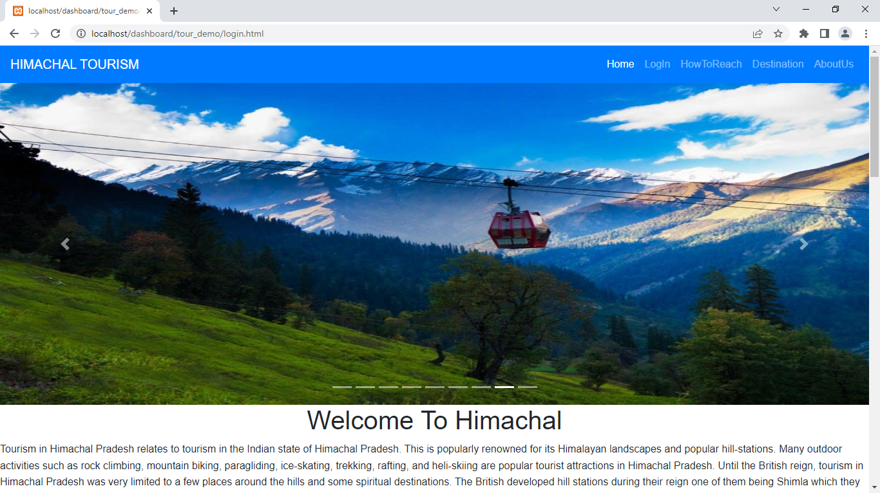

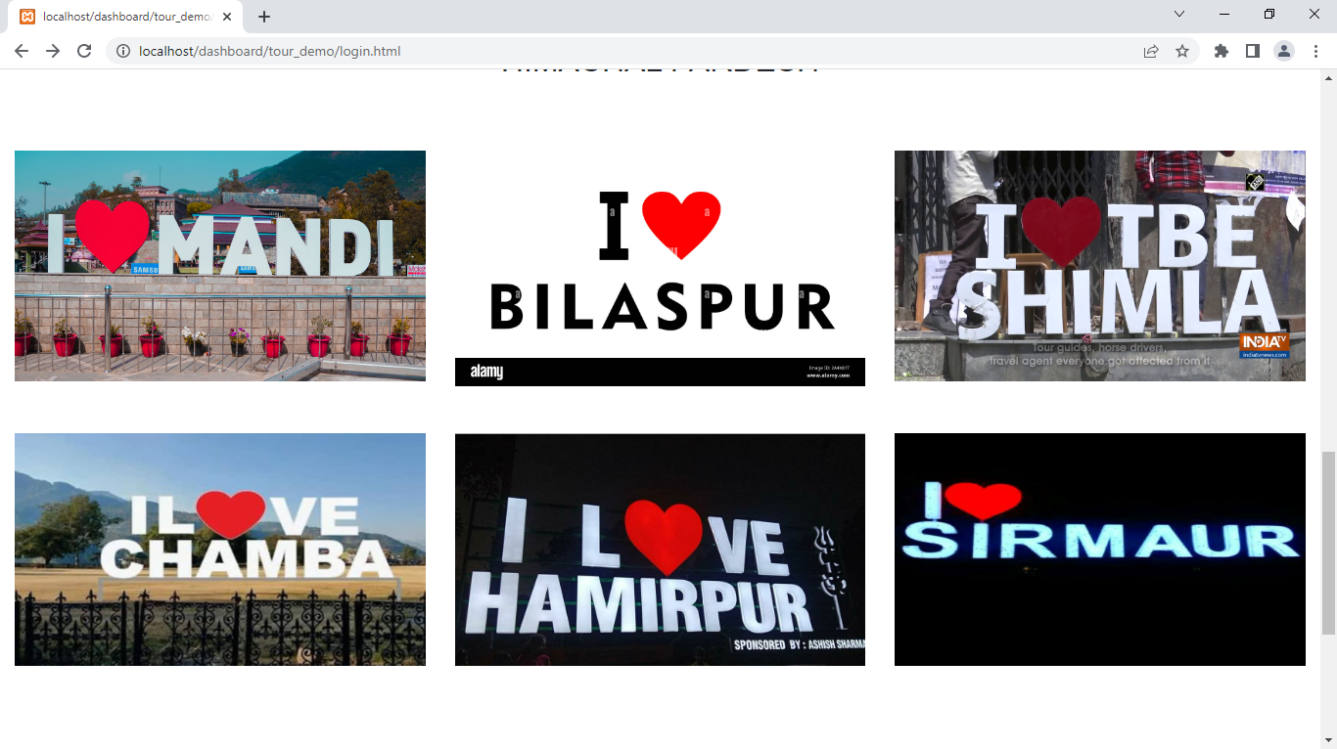

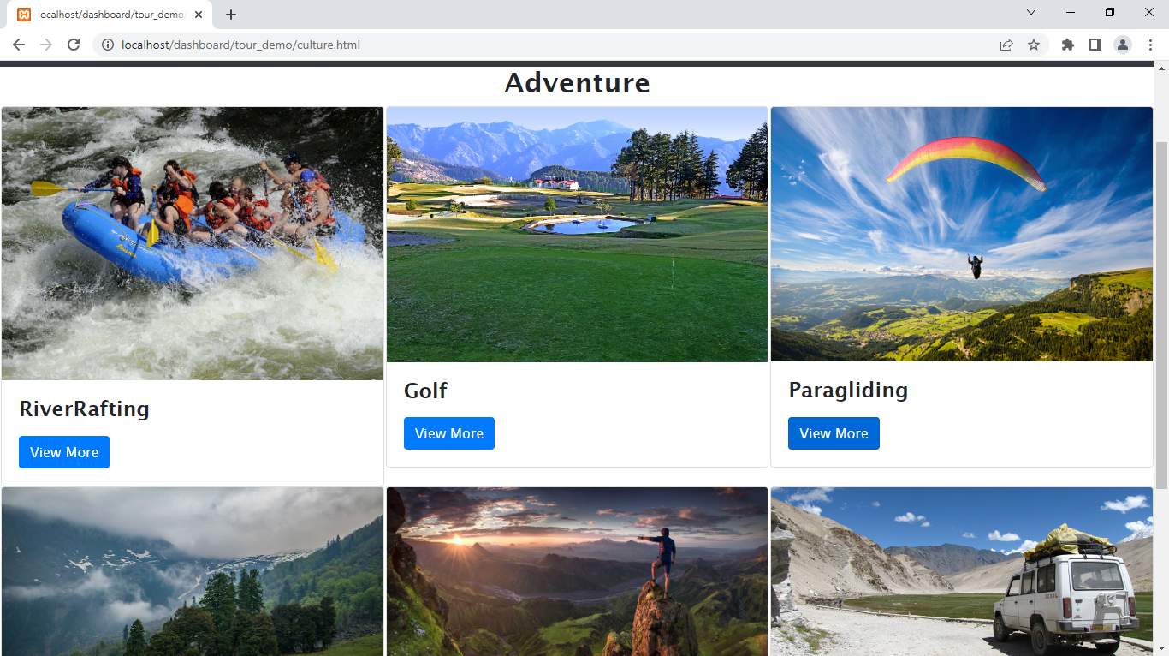

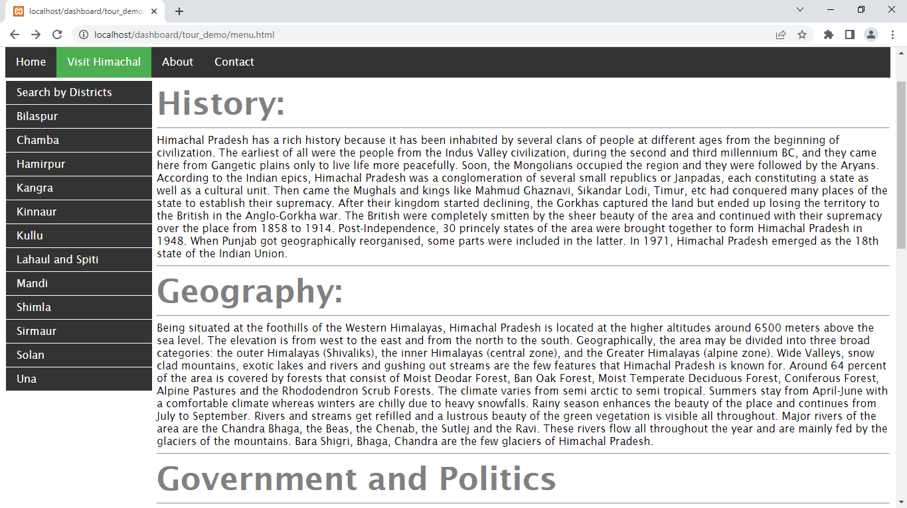

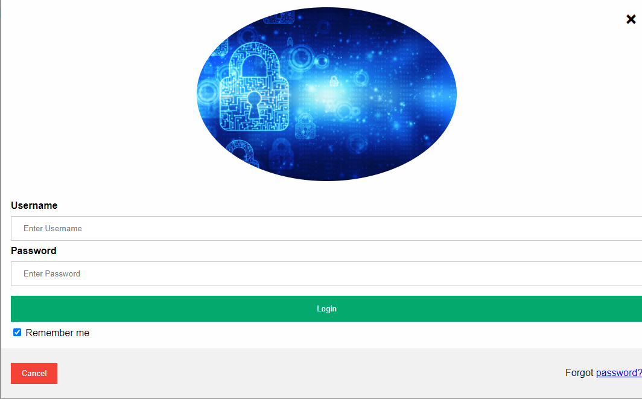

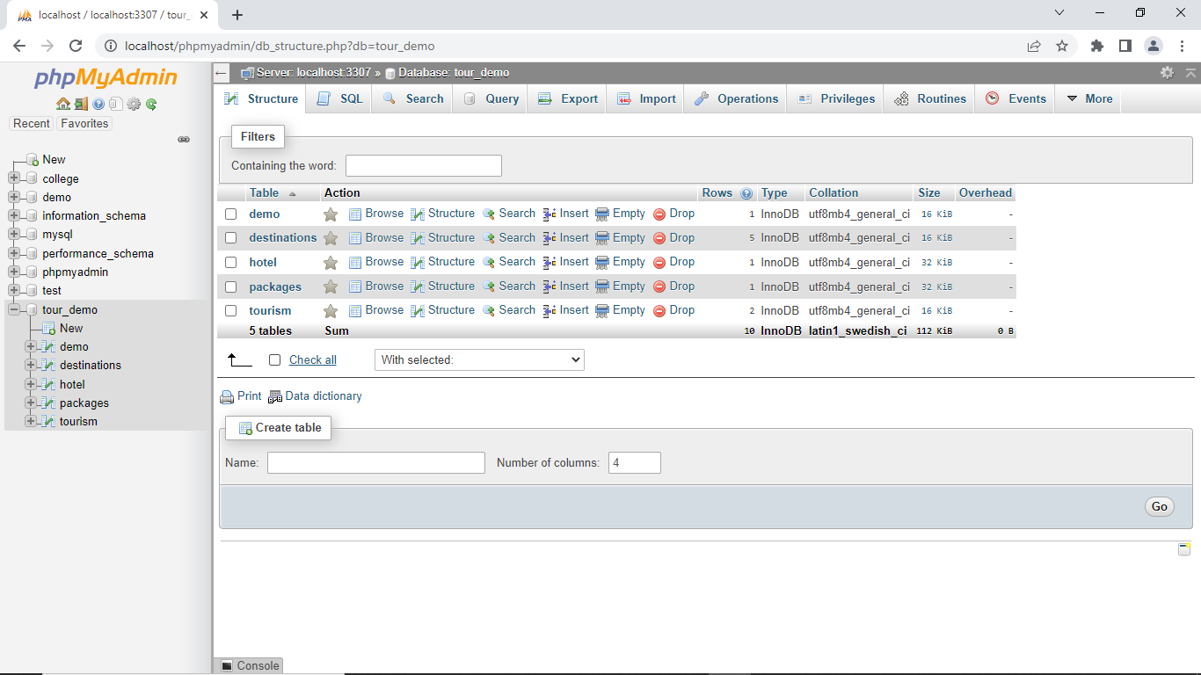

**SCOPE OF THE PROJECT**

The simple aim of the project to help the tourists to choose the best places to visit in Himachal Pradesh according to their choice.We have provided all destinations, packages and services under Himachal Pradesh.It helps to find best palces to visit in Himachal Pradesh.